CHAPTER ONE

INTRODUCTION

1.1 Background of the Study
Automated Teller Machines have become significant channels for the delivery of banking services because they provide customers with access to financial transactions outside the physical banking hall. Through ATM platforms, users are able to perform operations such as cash withdrawal, account balance enquiry, fund transfer, and deposit processing. Aljuaid and Ansari (2022) indicated that banks deploy ATMs in several locations to improve customer access to banking services; however, they also observed that ATM usage is associated with security challenges involving theft, forgery, card loss, and unauthorized account access. This implies that the convenience of ATM banking must be examined alongside the authentication risks associated with its use.
Traditional ATM authentication is largely dependent on the possession of a bank card and the use of a Personal Identification Number. This approach represents a combination of possession-based and knowledge-based verification, but it does not provide direct confirmation that the person using the ATM is the legitimate account owner. Aljuaid and Ansari (2022) reiterated that card-and-PIN-based ATM systems are vulnerable to fraudulent activities such as shoulder surfing, stolen cards, and fake PIN pads. Therefore, reliance on PIN-based authentication alone creates a security limitation because the verification process may be compromised when the card and PIN are obtained by an unauthorized person.
Multi-factor authentication has emerged as a response to the limitations of single-factor or weakly layered authentication systems. The National Institute of Standards and Technology [NIST] (2025) explained that authentication may involve different factors, including something possessed by the user, a memorized secret, and biometric comparison. In addition, NIST (2025) indicated that a combination of authenticators may include a physical authenticator together with either a password or biometric comparison. This shows that authentication systems can be strengthened when access control is designed around more than one independent factor.
Biometric authentication provides an additional layer of identity verification by using measurable human characteristics. The International Organization for Standardization [ISO] (2022) defines biometric recognition as the automated recognition of individuals based on biological and behavioural characteristics. Similarly, biometric systems compare a live biometric sample with a previously stored biometric reference in order to determine whether there is a probable match between the claimant and the enrolled identity. This implies that biometric verification can support ATM authentication by adding user-specific identity evidence that is more difficult to share, guess, or observe than a PIN.
The use of biometric authentication in ATM systems has been examined in previous studies as a method for strengthening access control. Aljuaid and Ansari (2022) proposed a biometric ATM authentication method based on multiple biometric measures and argued that biometric recognition could improve identification and authorization in ATM transactions. Their study also revealed that biometric authentication may reduce fraud and misuse by verifying the identity of the person attempting to access the banking service. Therefore, biometric authentication is relevant to ATM security because it provides a mechanism for validating the person rather than only validating the card and PIN.
In the present study, a multi-modal ATM authentication prototype was designed and implemented using card/PIN verification, SMS-based mobile handoff, and facial verification. The implemented system begins by verifying the user’s card number and PIN. After successful PIN verification, a temporary face-verification link is sent through SMS, and the user completes facial verification through a mobile-friendly web page. Access to ATM transactions is granted only when the PIN, and face verification stages are successfully completed before session expiry. This implemented workflow establishes the basis for examining how layered authentication can be applied to ATM security in a software prototype.

1.2 Statement of the Problem
Traditional ATM authentication systems rely primarily on card and PIN verification, making them vulnerable to security threats such as stolen cards, PIN theft, shoulder surfing, and social engineering attacks. Because these systems authenticate credentials rather than the actual identity of the user, unauthorized individuals who obtain a valid card and PIN may gain access to an account. This limitation creates a significant gap in user identity verification and raises concerns about the overall security of ATM transactions.
To address this challenge, there is a need for a more robust authentication approach that provides stronger assurance of user identity while remaining practical and reliable. Therefore, this study focuses on the weakness of conventional card-and-PIN-based ATM authentication by developing a multi-factor authentication prototype that integrates PIN verification, SMS-based mobile handoff, and facial verification to enhance security and reduce the risk of unauthorized access.

1.3 Aim of the Study
The aim of this study is to design and implement a multi-modal ATM authentication system that enhances ATM access security through the integration of PIN verification, SMS-based mobile verification, and facial verification.

1.4 Objectives of the Study
The specific objectives of the study are to:
- Design a multi-factor ATM authentication framework that integrates card/PIN verification, SMS-based mobile handoff, and facial verification.
- Develop and implement a web-based ATM system comprising user interfaces and backend services for user management, authentication processing, biometric verification, SMS delivery, transaction handling, and authentication logging.
- Implement authentication session management mechanisms, including token generation, stage-based verification, session expiry control, and restricted access to transaction functions until all authentication requirements are satisfied.
- Test and evaluate the functionality and reliability of the system components, including biometric verification, SMS services, security controls, data validation, and authentication processes.

1.5 Significance of the Study
The study is significant because it demonstrates how ATM authentication can be strengthened through layered identity verification. Traditional card-and-PIN verification confirms possession and knowledge, but it does not sufficiently confirm the physical identity of the user. By incorporating face verification, the implemented system introduces biometric identity assurance into the authentication process. This contributes to the broader discussion on ATM security and multi-factor authentication.
In addition, the study is relevant to financial technology and banking security research. Aljuaid and Ansari (2022) reported that biometric techniques can support ATM security by strengthening identification and authorization. In the same direction, the present study implements a prototype that combines knowledge-based, possession-based, and biometric factors. This implies that the project may serve as a foundation for further research on secure ATM authentication and biometric banking systems.

1.6 Scope of the Study
The scope of this study is limited to the design and implementation of a web-based multi-factor ATM authentication prototype. The implemented system covers user enrolment, card and PIN verification, SMS-based mobile face verification, authentication session tracking, authentication logging, and basic banking operations. The basic banking operations include balance enquiry, withdrawal, deposit, and transfer.
The ATM interface is presented through a browser-based simulation, while the facial verification stage is performed through a mobile-friendly web page accessed through an SMS link or QR code. These implementation details show that the study is focused on software prototyping rather than physical ATM hardware deployment.
The study does not include integration with real ATM card readers, cash dispensers, receipt printers, or core banking infrastructure. It also does not include production-grade liveness detection, formal biometric accuracy evaluation, account lockout, rate limiting, encrypted biometric template storage at the application level, or real-time fraud monitoring. Therefore, the project should be interpreted as a functional prototype for demonstrating layered ATM authentication rather than as a production-ready banking system.

1.7 Limitations of the Study
The first limitation of the study is that the implemented system is a software prototype. It simulates ATM authentication and transaction processing through browser-based interfaces and backend APIs, but it is not connected to real ATM hardware or banking infrastructure. This limits the extent to which the system can be directly generalized to operational banking environments.
The second limitation concerns biometric evaluation. The implemented system performs face verification, but no formal biometric dataset evaluation was conducted. As a result, the study does not report biometric performance metrics such as false acceptance rate, false rejection rate, equal error rate, or operational accuracy. This limitation is important because biometric systems require empirical evaluation before deployment in high-security environments.
The third limitation relates to spoofing and liveness detection. The implemented system does not include face liveness detection, anti-replay protection, or presentation attack detection. NIST (2025) identifies presentation attack detection as a relevant concern in biometric authentication contexts. Therefore, the absence of liveness and anti-spoofing mechanisms limits the production security of the prototype.

1.8 Operational Definition of Terms
Automated Teller Machine: An electronic banking system that enables users to perform financial transactions such as withdrawal, balance enquiry, deposit, and transfer without direct bank staff involvement.
Authentication: The process through which a system verifies that a user or claimant is authorized to access a service or resource.
Multi-Factor Authentication: An authentication approach that requires more than one verification factor, such as something the user knows, something the user has, or something the user is.
Personal Identification Number: A secret numeric code used as a knowledge-based factor for verifying a user during ATM access.
Biometric Recognition: The automated recognition of individuals based on biological or behavioural characteristics, as defined by ISO (2022).
Facial Verification: A biometric verification method that compares a captured face image with a stored face encoding or facial reference.
SMS-Based Mobile Handoff: A verification process in which a temporary authentication link is sent to the user’s mobile phone, allowing the user to continue authentication on a mobile device.
Authentication Session: A temporary system record used to track the user’s progress through the authentication stages.
Token: A secure temporary value used to identify and validate an authentication request within a defined expiry period.

CHAPTER TWO

LITERATURE REVIEW

2.1 Conceptual Review

2.1.1 Automated Teller Machine Authentication
Automated Teller Machine authentication refers to the process through which an ATM system verifies that a user is authorised to access a bank account or perform a banking transaction. In traditional ATM systems, this process is usually based on the presentation of a bank card and the entry of a Personal Identification Number. The card provides account-related identification data, while the PIN serves as a secret knowledge credential that is expected to be known only to the account holder. This model has been widely adopted because it is simple, fast, and easy for customers to understand.
However, the simplicity of card-and-PIN authentication also creates a structural weakness. The ATM does not directly know whether the person presenting the card and PIN is the legitimate customer; it only verifies whether the credentials match the stored records. This means that authentication is focused on the validity of credentials rather than the identity of the person using them. Therefore, once an unauthorised person obtains both the card details and the PIN, the system may treat the person as a legitimate user.
In addition, ATM authentication takes place in a physical environment where the user may be exposed to shoulder surfing, card trapping, skimming devices, hidden cameras, and social engineering. The FBI (n.d.) explains that skimming is commonly associated with the unauthorised capture of card information through devices placed on card readers. This indicates that ATM credentials can be compromised without the direct consent of the user. As a result, secure ATM design requires additional verification layers that can reduce the effect of stolen or copied credentials.
Furthermore, ATM authentication is time-sensitive because the user expects immediate access after entering the correct credentials. This requirement creates a design challenge for security systems because the authentication process must remain strong without becoming too slow or inconvenient. A system that is too complex may frustrate users, while a system that is too simple may expose customers to fraud. Therefore, ATM authentication must balance usability, speed, accessibility, and security.
In the present project, ATM authentication is treated as a staged process rather than a single credential check. The user first enters card and PIN information through the ATM interface. After successful PIN verification, the backend creates an authentication session and generates a temporary face-verification token. The customer then completes facial verification through a mobile browser link sent by SMS or accessed through QR fallback. Access to ATM operations is granted only after the facial verification succeeds before token expiry. This design shows that authentication is not completed at the PIN stage but only after identity confirmation has been achieved.

2.1.2 Personal Identification Number in ATM Security
A Personal Identification Number is a secret numeric code used to verify a user during ATM access. It is an example of knowledge-based authentication because the security of the process depends on something the user knows. In ATM systems, the PIN is normally compared with a stored or hashed value associated with the account or card record. If the entered PIN corresponds with the stored record, the user is allowed to proceed to the next stage of access.
The PIN remains important because it provides a simple and familiar method of user verification. Customers can enter PINs quickly, and banks can verify them without requiring complex hardware at every transaction point. However, the PIN is not a strong identity factor by itself because it can be shared, observed, guessed, coerced, or stolen. Therefore, PIN authentication is better understood as proof of knowledge rather than proof of personal identity.
In addition, PIN security is affected by human behaviour. Users may choose weak PINs, reuse PINs across multiple services, disclose PINs to relatives or agents, write PINs down, or enter them in insecure environments. Even where the technical system stores PINs securely, the human side of PIN management can weaken the overall authentication process. This implies that ATM security cannot depend only on the assumption that the PIN will always remain secret.
Furthermore, PIN-based authentication is vulnerable when combined with card compromise. A stolen card alone may not be sufficient to access an account, and a PIN alone may not provide access without card information. However, when both are compromised, the system may not have an additional method of determining whether the user is genuine. This is the central security problem that justifies the use of additional authentication factors in the present project.
In the implemented system, the PIN is retained as the first verification layer rather than removed. This is important because the project does not reject traditional ATM authentication entirely; it strengthens it. The PIN serves as the knowledge factor, while the mobile handoff and facial verification provide additional layers of assurance. Therefore, the system is designed to improve ATM authentication by building upon the existing PIN model rather than replacing it with biometric verification alone.

2.1.3 Concept of Multi-Factor Authentication
Multi-factor authentication refers to a security process that requires two or more independent forms of verification before access is granted. These factors are commonly grouped into knowledge factors, possession factors, and inherence factors. Knowledge factors include passwords and PINs; possession factors include mobile phones, tokens, or smart cards; inherence factors include biometric traits such as face, fingerprint, or iris. NIST (2022) states that multi-factor authentication improves security because an attacker must compromise more than one type of credential to gain unauthorised access.
The value of multi-factor authentication lies in the independence of its factors. If all factors depend on the same type of evidence, the security improvement may be weak. For example, a password and another memorised code are both knowledge factors, so compromise of the user’s memory-based secrets may affect both. In contrast, combining a PIN, registered mobile phone access, and facial biometric verification introduces different forms of evidence. This makes the authentication process more resistant to single-point compromise.
Recent literature on digital payment systems also supports the importance of multi-factor authentication. Tran-Truong et al. (2025) reviewed multi-factor authentication practices in digital payment systems and assessed their alignment with NIST digital identity guidelines. Their review indicates that authentication in financial environments must be evaluated not only by the number of factors used but also by the assurance level, implementation quality, and security risks associated with each factor. Therefore, multi-factor authentication must be designed carefully rather than treated as a mere addition of multiple steps.
Furthermore, Carrillo-Torres et al. (2023) proposed a multi-factor authentication mechanism based on image selection and user-established relations, showing that recent research continues to explore alternative authentication factors that improve password-based systems. Although their work is not ATM-specific, it supports the wider argument that single-factor authentication is insufficient for many modern access-control environments. This is relevant to ATM security because financial access systems require stronger assurance than ordinary low-risk login systems.
In the present study, multi-factor authentication is implemented through a staged verification process. The PIN represents what the user knows. The SMS-based mobile handoff links the authentication attempt to the registered phone number and provides an out-of-band step. The facial verification confirms who the user is by comparing the live selfie with the enrolled face template. Therefore, the system reflects a layered authentication model that is more secure than a single card-and-PIN check.

2.1.4 Biometric Authentication
Biometric authentication is the process of verifying an individual’s identity through measurable physical or behavioural characteristics. Physical biometric traits include face, fingerprint, iris, retina, palm print, and finger vein patterns, while behavioural biometric traits include voice, keystroke rhythm, signature, and gait. Jain et al. (2011) explain that biometric systems use these traits to establish or verify identity because they are linked to the individual rather than to a transferable credential. This makes biometrics useful in systems where identity assurance is important.
Biometric authentication normally involves two major stages: enrolment and verification. During enrolment, the system captures a biometric sample from the user and converts it into a stored template or feature representation. During verification, the system captures a new sample and compares it with the enrolled template. If the similarity is within an accepted threshold, the user is verified. Therefore, the reliability of biometric authentication depends on the quality of the captured sample, the stability of the biometric trait, the accuracy of the comparison method, and the security of the stored template.
In financial services, biometric authentication is attractive because it can reduce dependence on passwords, PINs, and tokens that may be forgotten, shared, stolen, or lost. FSD Africa (2017) explained that biometrics can be used in digital financial services for both identification and verification, where identification involves one-to-many matching and verification involves one-to-one matching. The present project uses biometric verification rather than biometric identification because the system compares the captured face with the face template linked to a specific account/session rather than searching across all users.
However, biometric authentication also introduces risks that must be managed carefully. Unlike passwords and PINs, biometric traits cannot be easily changed if compromised. If a PIN is exposed, it can be reset. If a facial template is exposed, the user cannot replace their face. Jain, Nandakumar, and Nagar (2008) noted that biometric template security requires attention to privacy, revocability, diversity, and resistance to attacks. This indicates that biometric systems must include strong storage, access control, encryption, and template protection measures.
Furthermore, biometric systems are affected by presentation attacks, environmental conditions, device quality, and user behaviour. A face verification system may be affected by poor lighting, camera quality, facial angle, obstruction, ageing, or attempted spoofing through printed images or screen replay. Therefore, biometric authentication should not be treated as perfect or absolute. It should be implemented as part of a broader security design that includes session control, token expiry, threshold management, and future liveness detection.

2.1.5 Facial Recognition in Authentication Systems
Facial recognition is a biometric technique that uses facial features to identify or verify a person. In verification mode, the system compares a newly captured face image with a stored template to determine whether both represent the same person. This is different from identification, where the system searches a database to determine who the person might be. In ATM security, face verification is more appropriate because the system already has a claimed identity from the card/PIN stage and only needs to confirm whether the person matches the enrolled account holder.
The facial recognition process generally includes face detection, feature extraction, template generation, and comparison. Face detection locates the face within the image. Feature extraction converts facial characteristics into a numerical representation. Template generation stores this representation in a format that can be compared later. During verification, the newly extracted face representation is compared with the stored template using a distance or similarity measure. Therefore, facial authentication depends not only on the captured image but also on the quality of the algorithm and threshold selected for comparison.
Otta et al. (2023) explained that facial recognition as an authentication factor involves interrelated processes required for matching a user’s face against stored data. This supports the idea that face authentication is not simply a camera-based process; it is a computational process involving image capture, preprocessing, representation, and decision-making. In financial authentication systems, this process is useful because it links access to a physical trait that is more difficult to share than a PIN.
In addition, facial recognition is particularly suitable for mobile-assisted ATM verification because modern mobile devices commonly include cameras. This reduces the need to install specialised biometric capture hardware on every ATM terminal. Instead, the ATM can initiate the authentication session, while the mobile device performs the face capture stage. This design is practical for a prototype because it uses existing user hardware and a browser-based verification page. Therefore, mobile facial verification provides a feasible method of adding biometric assurance to ATM access.
Recent work has also explored the use of facial recognition in multi-factor authentication systems. Han et al. (2024) proposed a CNN-based multi-factor authentication system for mobile devices using a face image, a password-derived image, and an auxiliary user-selected image. Their study indicates that face data can be combined with other authentication information in a multi-factor model, although the exact approach differs from the ATM prototype in the present study. This supports the broader relevance of combining facial biometrics with other credentials in modern authentication design.
However, facial recognition also raises important concerns. Face authentication may be vulnerable to spoofing if liveness detection is not implemented. It may also be affected by demographic bias, poor lighting, occlusion, and variations in facial expression or camera angle. Therefore, facial verification in this project should be presented as a prototype security enhancement rather than a fully production-ready biometric system. The system demonstrates the authentication workflow, but further evaluation would be required before deployment in real banking environments.

2.2 Theoretical Framework
The theoretical framework provides the intellectual basis for explaining why the proposed ATM authentication system is designed as a layered verification process rather than a single-stage access mechanism. Since the project focuses on PIN verification, SMS-based mobile handoff, QR fallback, and facial biometric verification, the appropriate theoretical foundation must account for authentication assurance, layered security, user identity verification, system usability, and controlled access to financial operations. Therefore, this section discusses the Multi-Factor Authentication Framework, Defence-in-Depth Security Theory, Zero Trust Architecture, Biometric Recognition Theory, and the Technology Acceptance Model.
These frameworks are relevant because ATM security is not only a technical issue but also an identity assurance problem. The traditional ATM model assumes that possession of a valid card and knowledge of the correct PIN are sufficient for access. However, this assumption becomes weak when the card and PIN are stolen, copied, exposed, or fraudulently obtained. Therefore, the proposed system is grounded in the view that access to financial resources should be granted only after multiple forms of verification have been satisfied.
In addition, the theoretical framework supports the staged workflow adopted in the project. The PIN stage confirms the knowledge credential, the SMS or QR handoff connects the ATM session to a registered mobile verification channel, and the facial verification stage confirms the user’s biometric identity. This structure aligns with the current implementation, where the active authentication flow is PIN verification followed by SMS/QR-based mobile facial verification. Therefore, the theories reviewed in this section provide a scholarly basis for the design decisions adopted in the system.

2.2.1 Multi-Factor Authentication Framework
The Multi-Factor Authentication Framework is one of the major theoretical foundations of this study because it explains the need to verify users through more than one authentication factor. Authentication factors are generally classified into knowledge factors, possession factors, and inherence factors. Knowledge factors include PINs and passwords; possession factors include cards, mobile phones, physical tokens, or authentication devices; inherence factors include biometric traits such as face, fingerprint, iris, or voice. The central assumption of multi-factor authentication is that access becomes more secure when an attacker must compromise more than one independent factor before gaining entry.
NIST (2025) explains that stronger authentication requires the use of either a multi-factor authenticator or a combination of separate authentication factors, depending on the required assurance level. This position is important because financial systems require a higher level of identity confidence than ordinary low-risk systems. In ATM security, the compromise of one factor should not automatically result in account access. Therefore, the use of PIN verification alone is theoretically weaker than a system that also requires mobile-based facial verification before access is granted.
The Multi-Factor Authentication Framework applies directly to the present project because the system combines more than one verification mode. The PIN represents the knowledge factor because it is based on a secret known by the user. The registered mobile handoff through SMS or QR-linked session represents an additional verification channel that connects the authentication attempt to the user’s mobile environment. Facial verification represents the inherence factor because it compares the user’s live facial capture with the enrolled face template. This combination improves the assurance level of the authentication process because the system no longer depends on only one form of evidence.
Furthermore, multi-factor authentication is relevant because ATM fraud often succeeds when attackers obtain card and PIN credentials. A system that stops at card-and-PIN verification may not distinguish between a legitimate customer and an attacker who has obtained the credentials. However, when facial verification is introduced after PIN verification, the attacker must also satisfy a biometric comparison linked to the account holder. Therefore, the framework supports the use of facial verification as a second-level identity assurance mechanism in the ATM access process.
In addition, the framework explains why the system should not grant access immediately after the PIN is entered correctly. Under a multi-factor structure, the PIN is only one stage in the authentication chain. The authentication session remains incomplete until the mobile verification and facial comparison are completed. This is reflected in the project’s active workflow, where the backend creates an authentication session after PIN verification, generates a face-verification token, sends the link by SMS or provides QR fallback, and waits until the mobile face verification step marks the session as authenticated.
However, the Multi-Factor Authentication Framework also requires careful implementation. The strength of a multi-factor system depends on the independence and security of each factor. If the SMS channel is compromised, or if the biometric comparison can be spoofed, the system may still be weakened. NIST (2025) also indicates that biometric-related authentication must consider presentation attack detection and injection attack resistance, especially in higher assurance contexts. This means that the prototype can be considered a functional demonstration of layered authentication, but future versions should include liveness detection and stronger biometric anti-spoofing controls.
Therefore, the Multi-Factor Authentication Framework provides the central theoretical justification for the present study. It supports the movement from PIN-only ATM access to a staged authentication process that combines knowledge-based verification, mobile-session handoff, and facial biometric verification. This makes it the most directly applicable framework for the design and implementation of the proposed ATM security system.

2.2.2 Defence-in-Depth Security Theory
Defence-in-Depth Security Theory provides another important foundation for this study because it explains the value of using multiple protective layers in a security system. The theory assumes that no single security control is perfect and that a system becomes more resilient when several independent controls are arranged to reduce the effect of failure at any one point. In information security, defence-in-depth is commonly applied through access control, authentication, monitoring, encryption, logging, network controls, and recovery mechanisms.
NIST SP 800-53 Revision 5 presents a broad catalogue of security and privacy controls designed to protect information systems and organisational assets against hostile attacks, human errors, structural failures, and privacy risks (Joint Task Force, 2020). Although the publication is not specific to ATM systems, it supports the general principle that secure systems should use coordinated controls rather than isolated safeguards. This principle is relevant to ATM authentication because the failure of a single control, such as PIN secrecy, should not automatically expose the user’s bank account.
The Defence-in-Depth Theory applies to the present project because the system uses several security layers before granting access. The first layer is card/PIN verification, which confirms that the user knows the account-related secret. The second layer is session creation and token control, which ensures that the authentication attempt is tracked and time-bound. The third layer is SMS or QR-based mobile handoff, which moves the biometric verification stage to a controlled mobile link. The fourth layer is facial verification, which checks the user’s biometric identity. The final layer is transaction access control, which allows banking operations only after the authentication session has been marked as successful.
This theory is particularly relevant because ATM security threats may occur at different points in the authentication process. A user’s PIN may be observed, card information may be skimmed, or an attacker may attempt to reuse a verification link. Defence-in-depth addresses these risks by ensuring that one compromised element does not automatically complete the authentication process. For example, even if the PIN is correct, the system still requires facial verification. Similarly, even if the mobile verification link is opened, the system still requires a successful face match before ATM operations are unlocked.
In addition, defence-in-depth supports the project’s use of token expiry. A temporary verification token reduces the risk of link reuse because the token remains valid only for a defined period. If the user does not complete facial verification before the token expires, the authentication attempt fails. This control is important because multi-stage authentication systems require session boundaries. Therefore, token expiry functions as a defensive layer that limits the time window available for misuse.
However, the theory also reveals some limitations in the current prototype. A complete defence-in-depth implementation would require production-grade biometric template encryption, rate limiting, administrator authentication for enrollment, real-time fraud monitoring, anti-spoofing controls, and transaction-level risk scoring.
Therefore, Defence-in-Depth Security Theory supports the design of the proposed system by explaining why ATM authentication should be protected through multiple layers. The theory justifies the combination of PIN verification, session control, mobile handoff, facial comparison, and authenticated transaction access. It also provides a basis for identifying future security improvements required before the system could be adapted to a production banking environment.

2.2.3 Zero Trust Architecture
Zero Trust Architecture provides a contemporary theoretical perspective for understanding why authentication should not rely on one successful checkpoint. The central idea of zero trust is that no user, device, session, or network position should be automatically trusted. Instead, each access request should be evaluated using identity, context, device state, policy, and risk. NIST SP 800-207 defines zero trust architecture as an approach that removes implicit trust and continuously evaluates access to resources (Rose et al., 2020). This principle is relevant to ATM security because an ATM should not assume that a user is legitimate merely because the correct PIN has been entered
The relevance of zero trust to this study lies in its rejection of implicit trust. Traditional ATM authentication can be interpreted as a trust-granting model because the system grants access once the card and PIN are accepted. However, in a zero trust-aligned model, the system continues to verify the user before allowing access to protected operations. Therefore, the proposed system reflects a limited zero trust logic by requiring the user to complete facial verification after PIN verification before transaction functions are unlocked.
In addition, zero trust supports the separation of authentication stages. The ATM interface does not immediately grant access after the PIN stage. Instead, the backend creates a session, generates a temporary mobile verification token, and waits for an independent face-verification result from the mobile interface. This means that the ATM interface cannot independently decide that the user is fully authenticated. Access depends on the backend authentication state. This design reduces implicit trust in the frontend and centralises the final access decision in the backend.
Furthermore, zero trust is relevant to session polling and transaction gating. The ATM page detects the authentication result by polling the backend, and transaction operations are unlocked only after the session stage becomes authenticated. This prevents the user interface from functioning as the sole authority for access.
Zero trust also supports the use of short-lived tokens. Since no session should be trusted indefinitely, the system must limit the period during which a verification link can be used. Token expiry ensures that an authentication link cannot remain valid after the expected verification window. This is important in ATM security because transaction sessions should be short, controlled, and resistant to reuse. Therefore, token expiry represents a practical implementation of continuous control in the proposed system.
However, the present system is not a full zero trust architecture. Full zero trust would require stronger device identity, richer context evaluation, continuous risk scoring, least-privilege policy enforcement, network segmentation, and production monitoring. The project does not claim to implement these enterprise-wide controls. Instead, zero trust is used as a theoretical guide to explain why the system should not trust one credential or one interface alone. This distinction is necessary because the project is an academic prototype rather than a complete enterprise security architecture.
Therefore, Zero Trust Architecture supports the study by explaining why access should be granted only after identity has been verified through more than one stage. It provides theoretical support for session-based authentication, mobile handoff, backend-controlled access decisions, temporary tokens, and transaction gating. This makes it relevant to the design of a secure ATM authentication prototype.

2.3 Empirical Review

2.3.1 Multi-Factor Authentication in Digital Payment and Banking Systems
Tran-Truong et al. (2025) conducted a systematic review of multi-factor authentication practices in digital payment systems. The study examined seventy academic papers published between 2017 and 2024 and thirteen industry-based authentication tools, with attention to their relationship with NIST identity assurance and authentication assurance standards. The review revealed that multi-factor authentication in digital payment systems must be evaluated not only by the number of factors used but also by the strength, independence, and assurance level of the factors. This finding is relevant to the present project because the proposed ATM security system combines PIN verification, SMS/mobile handoff, and face verification rather than treating the PIN as sufficient proof of identity.
The contribution of Tran-Truong et al. (2025) lies in their emphasis on authentication assurance rather than the mere addition of security steps. In many systems, a second factor may be weak if it depends on the same compromised device, channel, or credential source. Therefore, the quality of factor design is as important as the number of factors. In relation to the present study, this implies that the PIN, mobile verification link, and facial biometric comparison should be treated as distinct but connected stages within a controlled authentication workflow. This supports the system design adopted in the project, where access is not granted immediately after PIN verification.
Otta et al. (2023) conducted a systematic survey of multi-factor authentication for online banking. The study reviewed authentication methods used to protect online banking systems and discussed the relevance of facial recognition, fingerprint verification, iris recognition, passwords, one-time passwords, and other authentication mechanisms. The authors indicated that multi-factor authentication strengthens online banking protection by combining different verification categories, although each method has its own limitations. This study is relevant because ATM authentication and online banking authentication both involve controlled access to financial resources, even though the transaction environments differ.
Furthermore, Otta et al. (2023) showed that facial recognition can function as one component of a multi-factor authentication structure. This supports the present project’s use of facial verification as an additional identity confirmation stage after PIN verification. However, the study also implies that biometric systems must be evaluated alongside usability, security, and implementation risks. Therefore, the present project should be presented as a functional prototype rather than as a fully validated banking-grade authentication system.
Carrillo-Torres et al. (2023) proposed a multi-factor authentication algorithm based on image selection and user-established relationships. Although their study did not focus on ATM authentication, it contributed to the broader literature by showing that authentication systems can be strengthened through user-specific knowledge and visual interaction. The study is relevant because it reflects the continuing movement away from password-only systems towards authentication processes that require more than one type of user evidence. Therefore, it supports the general argument that ATM systems should not depend only on card and PIN authentication.
However, Carrillo-Torres et al. (2023) differs from the present project because it did not use biometric facial verification as the main identity-confirmation method. Instead, it focused on user-selected image relationships. The present study adopts a different route by using facial comparison through a mobile verification process. Therefore, the value of Carrillo-Torres et al. lies mainly in its support for multi-factor authentication as a security concept rather than as a direct ATM implementation model.
The World Bank (2023) also discussed customer authentication in fast payment systems and noted that authentication factors commonly include one-time passwords, biometric factors such as fingerprint or facial recognition, and possession-based mechanisms. The report is relevant because it shows that biometric factors are now part of mainstream discussions on financial authentication, especially in payment systems where security and convenience must be balanced. This supports the present project’s decision to integrate facial verification into an ATM authentication workflow.
The World Bank report further indicates that financial authentication must consider both user experience and risk. This is important because an ATM authentication system must be secure enough to prevent fraud but simple enough for customers to complete. Therefore, the proposed system’s SMS link and QR fallback are not merely technical additions; they are usability-supporting mechanisms that help users complete the facial verification stage through a mobile device.

2.3.2 Biometric Authentication in Banking and Financial Services
Widjaja (2025) examined the implementation of biometric technology to enhance the security and accessibility of digital financial services. The study reported that biometric systems such as fingerprint, facial recognition, and iris recognition can reduce identity theft risk and improve the user verification process. This finding is relevant to the present project because ATM fraud often occurs when an attacker possesses valid credentials but is not the legitimate account holder. Biometric verification therefore provides an additional means of linking access to the real user.
However, Widjaja’s study also implies that biometric implementation should not be treated only as a technical improvement. Accessibility, customer trust, privacy, and system reliability must also be considered. In the present project, this means that face verification should be implemented in a way that is understandable and usable for ordinary customers. The use of a mobile browser for facial verification is therefore relevant because many users already possess mobile phones with cameras, reducing dependence on specialised ATM hardware.
Anwar (2025) presented a multiple biometric authentication system for online banking within a multi-factor authentication framework. The study implemented multiple biometric authentication using a fuzzy logic approach and positioned biometric authentication as part of a broader MFA structure. Although the study is focused on online banking rather than ATM security, it is relevant because it supports the use of biometric evidence in financial access control. It also shows that recent research continues to investigate biometric authentication as a way of strengthening banking security.
The relevance of Anwar’s work to the present project lies in the shared concern with financial user verification. Online banking and ATM systems differ in user interface and transaction context, but both require assurance that the person requesting access is the legitimate account holder. The present study differs by implementing a software-based ATM prototype using PIN, SMS/mobile handoff, and facial verification. Therefore, Anwar’s work supports the biometric authentication direction while the present project applies it specifically to ATM access control.
A 2025 study on biometric technology and customer satisfaction in the fintech sector examined how fingerprint, facial recognition, and iris scanning relate to user experience and financial technology services. The study reported that biometric systems are increasingly integrated into financial services and may influence customer satisfaction through security, convenience, and trust. This is relevant because ATM authentication must not only prevent unauthorised access but also remain acceptable to users.
Nevertheless, customer satisfaction cannot be assumed merely because biometrics are used. Some users may have concerns about privacy, failed recognition, data misuse, or inconvenience. Therefore, the present project should not claim that facial verification will automatically improve customer satisfaction. Rather, it should be argued that a well-designed biometric authentication workflow may improve perceived security and trust if implemented with strong privacy and usability controls.
FSD Africa (2017), though older than the preferred 2022–2025 range, remains relevant because it provides a financial-sector perspective on biometric use in digital financial services. The report explains that biometrics may be used for customer identification, verification, authentication, and financial inclusion. Its relevance to the present study is based on its distinction between identification and verification. The present project uses verification because the system compares the captured face with the enrolled face linked to a specific user account rather than searching across a large population. This distinction prevents overstatement of the system’s function and keeps the project aligned with its actual implementation.
Therefore, the empirical literature on biometric authentication in financial services supports the use of biometric verification as an additional layer of identity assurance. However, it also indicates that biometric systems require careful design because they introduce issues of trust, privacy, accessibility, and template protection. This supports the present project’s decision to implement facial verification while acknowledging that further improvements, especially liveness detection and stronger biometric data protection, are required for production deployment.

2.3.3 Studies on Facial Recognition for ATM Security
Several recent studies have examined facial recognition as a method for strengthening ATM authentication. A study titled Face Biometric Authentication System for ATM using Deep Learning proposed the use of facial recognition to provide an additional security layer for ATM transactions. The study argued that facial recognition can improve ATM security because it checks whether the person attempting to access the ATM corresponds with the account owner. This is directly relevant to the present project because the same security gap exists in card-and-PIN authentication.
However, the present project differs from many face-based ATM studies because it does not assume that the ATM terminal itself must contain the camera. Instead, the face verification stage is completed through a mobile browser after an SMS/QR handoff. This makes the project’s design more flexible at the prototype level because it uses the customer’s mobile device for face capture. Therefore, the related ATM facial recognition studies support the use of face verification but do not fully represent the mobile-assisted architecture adopted in the present system.
A 2024 study on a multi-banking ATM system using biometrics proposed an ATM security model involving multiple authentication levels, including facial verification, fingerprint verification, and one-time password verification. The study presented biometric verification as a way of improving ATM security beyond traditional credentials. Its relevance to the present project lies in its recognition that ATM access can be strengthened through layered verification.
Nevertheless, the 2024 multi-banking ATM study differs from the present project because it included fingerprint verification, while the current prototype uses facial verification through mobile handoff. The difference is important because the present project does not implement fingerprint capture hardware or ATM-side biometric sensors. Therefore, the related study supports the general direction of biometric ATM authentication, while the present study contributes a software-based alternative using PIN, SMS/QR link delivery, and mobile face verification.
Patil et al. (2025) presented a prototype for a next-generation ATM using biometric and facial authentication with readily available hardware components. The study indicated that ATM security can be improved by incorporating biometric and facial authentication into the user access process. This supports the present project’s premise that ATM authentication should not remain limited to traditional card and PIN verification.
However, Patil et al. (2025) appears to focus on a hardware-oriented prototype, while the present project focuses on a web-based ATM simulation, FastAPI backend, database-supported authentication sessions, SMS/QR handoff, and mobile facial verification. This distinction is significant because software-based prototyping can demonstrate authentication logic before hardware deployment. Therefore, the present study is positioned as a functional software prototype rather than a hardware ATM replacement.
A 2025 study on integrated facial recognition and SMS alerts for ATM security proposed the use of facial biometrics and contextual alerting to respond to real-world fraud scenarios such as card skimming. The study is relevant because it combines facial recognition with communication-based security alerts, which is conceptually close to the present project’s use of SMS in the authentication workflow.
However, the present project uses SMS primarily for mobile verification handoff rather than only for alerting. This difference is important because the SMS message in the present system is part of the authentication process itself. It carries a temporary verification link that allows the user to complete face verification through a mobile browser. Therefore, the present system moves beyond notification by using SMS as a bridge between the ATM session and biometric verification.
Taken together, studies on facial recognition for ATM security show that face verification is widely regarded as a useful method for strengthening ATM access. However, many studies focus either on direct ATM camera integration or hardware-based biometric systems. The present project contributes differently by implementing a software-based authentication workflow that uses SMS/QR handoff and mobile browser face capture. This approach is particularly suitable for an academic prototype because it demonstrates the security process without requiring real ATM hardware.

2.3.4 SMS, OTP, and Out-of-Band Authentication
SMS and one-time password mechanisms are widely used in financial authentication because they provide an additional verification channel beyond the primary login interface. In many systems, SMS is used to deliver a one-time code or verification link. In the present project, SMS is used to deliver a temporary mobile face-verification link after PIN verification. This makes SMS an enabling channel for biometric verification rather than the final authentication factor.
The World Bank (2023) identified one-time passwords and biometric factors as common authentication methods in fast payment systems. This shows that communication-based verification and biometric verification are often considered together in modern financial authentication design. The present project follows this logic by using SMS to connect the user to a biometric verification stage.
However, SMS-based authentication has known limitations. NIST (2025) emphasises that authentication mechanisms must account for the security of communication channels, authenticator control, and resistance to compromise. This is important because SMS delivery may be affected by SIM-swap attacks, device theft, message interception, or delays. Therefore, the present project should not present SMS as a perfect security factor. Instead, SMS should be described as a practical handoff mechanism that enables mobile face verification within the prototype.
In the present system, QR fallback is included to reduce dependence on SMS delivery alone. If the SMS link is delayed or unavailable, the user can scan the QR code displayed on the ATM interface and proceed to the same mobile face-verification page. This design improves usability but still requires token-based control because the QR code should not grant access by itself. Access is granted only after the backend verifies the user’s face and updates the authentication session.
Therefore, empirical and standards-based literature on SMS and out-of-band authentication supports the present system only when SMS is treated carefully. SMS is useful for linking the ATM session to the user’s mobile device, but it must be combined with token expiry, backend validation, and facial verification. In future versions, stronger approaches such as secure mobile apps, device binding, and push-based authentication may offer higher assurance than SMS links alone.

CHAPTER THREE

SYSTEM ANALYSIS AND METHODOLOGY

3.1 Research Design
The research design adopted for this study is a design and implementation research design. This design is appropriate because the study does not only investigate an existing problem but also develops a practical software solution to address it. The study identifies the weakness of traditional ATM authentication and implements a prototype that improves access control through multi-stage verification. Therefore, the design is both analytical and developmental.
The analytical aspect of the study involves the examination of the existing ATM authentication process, particularly the reliance on card and PIN credentials. The developmental aspect involves the design and implementation of a prototype system that verifies the user through PIN authentication, generates a temporary mobile verification link, sends the link through SMS or provides a QR fallback, captures the user’s facial image through a mobile browser, compares the image with the enrolled face template, and grants access only when verification succeeds.

3.2 System Development Methodology
The system development methodology adopted for the project is the prototype model. The prototype model allows a system to be developed in stages so that its major functions can be implemented, tested, and improved progressively. This model is suitable for the present study because the project involves several interacting components, including the ATM interface, backend authentication service, database, SMS service, mobile face verification page, and transaction module.
The development process began with requirement analysis. At this stage, the security problem was identified, and the system requirements were defined. The main requirement was to develop a system that would not grant ATM access immediately after PIN verification. Instead, the system would require the user to complete facial verification through a mobile link before transaction access could be granted.
The next stage was system design. At this stage, the architecture of the proposed system was developed. The system was designed to include a web-based ATM interface, a FastAPI backend, a PostgreSQL, an SMS delivery service, and a mobile browser interface for face verification. The architecture was designed to separate the ATM session from the mobile biometric verification process while maintaining backend control over the authentication state.
The third stage was database design. The database was designed to store user records, account details, authentication sessions, transaction records, and authentication logs. This was necessary because the system needed to track users, PIN hashes, enrolled face templates, session tokens, authentication stages, transaction activities, and verification results.
The fourth stage was implementation. The backend was implemented with FastAPI, while the frontend interfaces were implemented using HTML, CSS, and JavaScript. The ATM interface accepts card and PIN details, while the mobile interface captures the user’s selfie for facial verification. The backend manages the authentication workflow, verifies PINs, generates tokens, sends SMS links, compares face encodings, and grants or denies access based on verification results.
The final stage was testing. The system components were tested to confirm that important functions worked correctly. These tests covered PIN hashing and verification, token generation, expiry helpers, face distance calculation, face encoding serialization, multi-angle face-template averaging, SMS development-mode behaviour, phone masking, and request schema validation. This confirms that the core utility components of the prototype function as expected, although full live end-to-end testing with a real database, Twilio SMS, mobile browser camera, and real face images still requires manual testing.

3.3 Analysis of the Existing System
The existing ATM authentication system was examined to identify its operational approach and security limitations. The analysis showed the following:
- The system relies mainly on ATM card details and PIN verification to authenticate users and grant access to banking services.
- Authentication is based on validating credentials rather than confirming the actual identity of the person performing the transaction.
- An unauthorized user who obtains both the ATM card and PIN may gain access to the account, exposing the system to security risks.
- Once the correct PIN is entered, the user is considered authenticated, creating a heavy dependence on a single authentication factor.
- The system does not typically incorporate biometric verification or mobile-assisted identity confirmation as part of the authentication process, limiting its ability to provide stronger identity assurance.

3.4 Description of the Proposed System
The proposed system is a web-based ATM authentication prototype that improves ATM security through multi-stage authentication. The system combines PIN verification, SMS-based mobile handoff, QR fallback, and facial biometric verification. It is designed to ensure that a user is not granted access to ATM transaction functions until both the PIN and face verification stages have been completed successfully.
The system begins when the user enters card and PIN details through the ATM interface. The backend verifies the card number and PIN. If the PIN verification fails, access is denied. If the PIN verification succeeds, the backend creates an authentication session and generates a temporary face-verification token. The token is then used to create a mobile verification link.
After the token is created, the system sends the mobile verification link to the user’s registered phone number through SMS. In addition, the ATM interface provides a QR code fallback so that the user can scan the code and open the mobile verification page. The use of both SMS and QR fallback improves accessibility because the user has more than one way to reach the mobile verification page.
The user then opens the link on a mobile device and captures a selfie through the mobile browser. The captured face image is submitted to the backend, where the system extracts the facial encoding and compares it with the enrolled face template stored for the user. If the face verification succeeds before the token expires, the authentication session is marked as authenticated. The ATM interface then detects the successful session status and unlocks the transaction menu.
The proposed system also supports multi-angle face enrollment. During enrollment, multiple face images can be uploaded from different angles. The backend extracts valid face encodings from the uploaded images and combines them into one averaged face template. This face template is then stored and used for future verification.

3.6 System Architecture
The proposed system is made up of five major components: the ATM frontend interface, the FastAPI backend, the database, the SMS service, and the mobile face verification interface. These components interact to provide a complete authentication workflow.
The ATM frontend interface serves as the user entry point for the simulated ATM system. It allows the user to enter card and PIN details, request mobile face verification, monitor authentication status, and access transaction options after successful authentication. The frontend communicates with the backend through API requests.
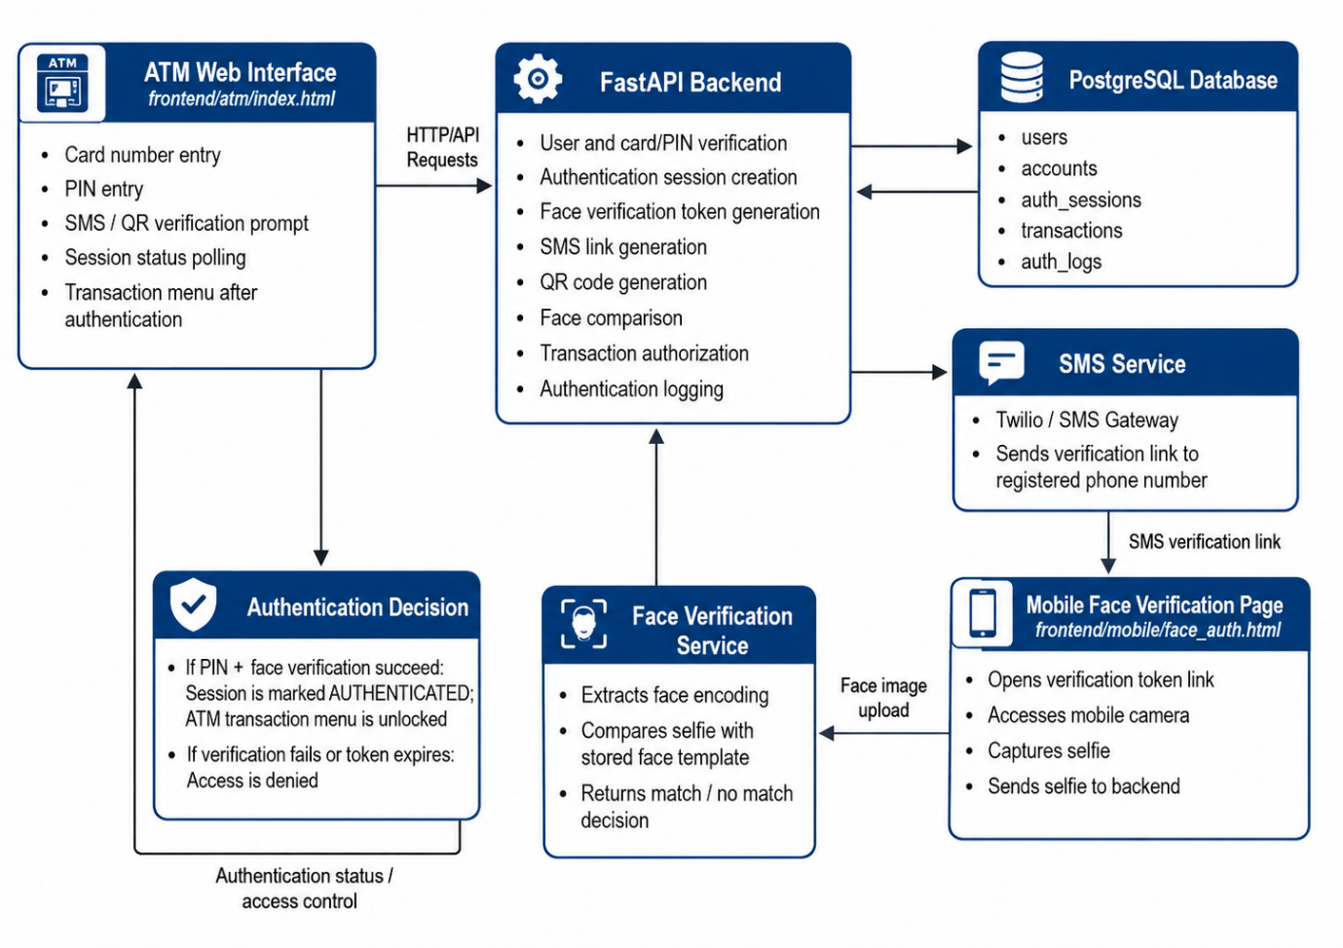
Figure 3.1: Proposed System Architecture
The FastAPI backend manages the core authentication logic. It verifies card and PIN details, creates authentication sessions, generates temporary tokens, sends SMS links, validates mobile verification requests, compares face encodings, updates authentication status, and controls access to transaction operations. It functions as the central decision-making layer of the system.
The database stores the records required for authentication and transaction processing. It contains user details, account records, authentication sessions, transaction history, and authentication logs. The database also stores important fields such as PIN hashes, face encodings, face-verification tokens, session stages, and expiry timestamps.
The SMS service delivers the mobile verification link to the user’s registered phone number. The system supports development-mode SMS behaviour as well as Twilio SMS providers. This allows the prototype to function in both testing and deployment-related environments.
The mobile face verification interface allows the user to complete biometric verification. It validates the face-verification token, starts the mobile camera, captures a selfie, and submits the image to the backend for comparison. If the backend verifies the face successfully, the session is marked as authenticated.

3.7 Authentication Workflow of the Proposed System
The authentication workflow of the proposed system follows a staged process. The process begins at the ATM interface and ends only when the backend confirms that the user has passed both PIN and facial verification. The stages are described below.
The first stage is card and PIN entry. The user provides card details and PIN through the ATM interface. These details are sent to the backend for verification. The backend checks whether the card exists and whether the submitted PIN matches the stored hashed PIN.
The second stage is authentication session creation. If the PIN is correct, the backend creates an authentication session for the user. This session records the user’s authentication progress and includes expiry control. The session is not yet considered fully authenticated at this stage.
The third stage is face-token generation. The backend generates a temporary token for mobile face verification. This token connects the mobile verification request to the ATM authentication session. The token is time-bound so that the verification link cannot be used indefinitely.
The fourth stage is SMS and QR handoff. The backend sends the mobile face-verification link to the user’s registered phone number through SMS. At the same time, the ATM interface can display a QR code fallback linked to the same verification process. This allows the user to open the face-verification page on a mobile device.
The fifth stage is mobile selfie capture. The user opens the verification link on a mobile browser and captures a selfie. The captured image is submitted to the backend for facial comparison.
The sixth stage is facial verification. The backend extracts the face encoding from the submitted selfie and compares it with the enrolled face template stored in the database. If the distance between the submitted face and stored template is within the configured threshold, the face verification is accepted.
The seventh stage is access decision. If the face verification succeeds before the session expires, the session is marked as authenticated. The ATM interface detects this status and unlocks the transaction menu. If the verification fails or the token expires, access is denied.
The active authentication workflow can be represented as follows:
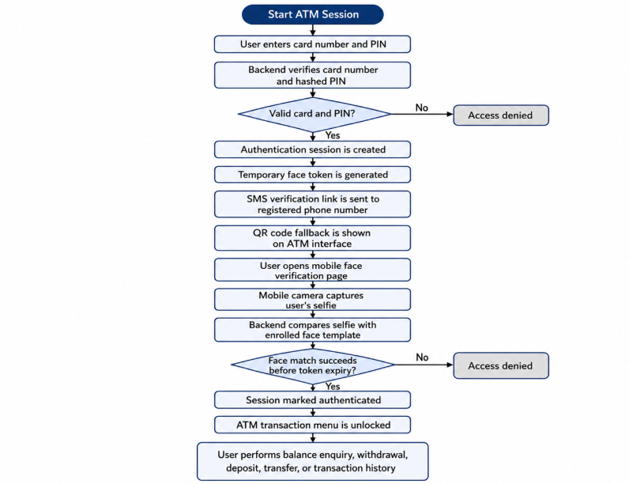
Figure 3.2: Authentication Flow Diagram

3.8 Database Design
The database design supports user authentication, account management, session tracking, transaction processing, and authentication logging. The project uses the major database tables as users, accounts, auth_sessions, transactions, and auth_logs.
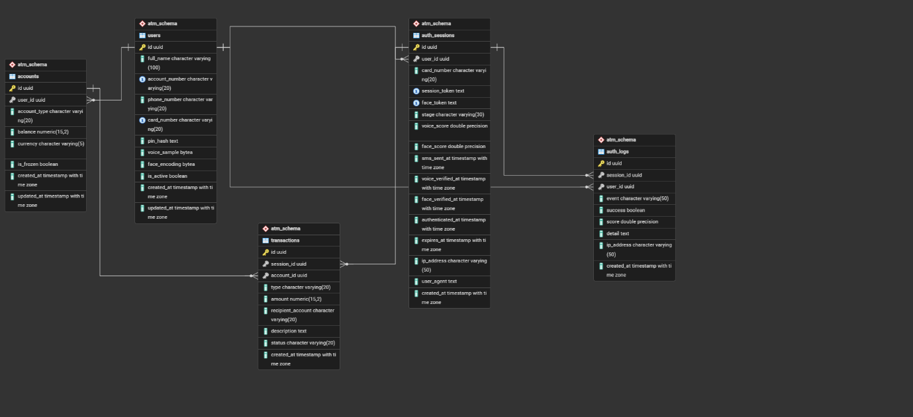
Figure 3.3: Database Relationship Diagram
The users table stores user identity and authentication-related information. It contains fields such as user identity details, account number, phone number, card number, PIN hash, face encoding, active status, and timestamps. The PIN hash is used for secure PIN verification, while the face encoding is used as the stored biometric template for facial comparison.
The accounts table stores account-related information. It contains the account balance, account type, currency, frozen status, and timestamps. This table is used when authenticated users perform banking operations such as balance enquiry, withdrawal, deposit, and transfer.
The auth_sessions table stores authentication session details. It contains the authentication stage, temporary tokens, biometric scores, expiry time, IP address, user agent, and timestamps. This table is important because the system uses staged authentication rather than granting access immediately after PIN verification.
The transactions table stores records of banking operations. It contains transaction type, amount, account details, and timestamps. This allows the system to keep a history of withdrawals, deposits, transfers, and balance-related activities.
The auth_logs table stores authentication-related events. It provides an audit trail for activities such as PIN verification, SMS sending, face verification, session authentication, failed attempts, and expired sessions. This table supports accountability and monitoring.

CHAPTER FOUR

SYSTEM IMPLEMENTATION AND TESTING

4.1 System Implementation
The proposed ATM authentication system was implemented as a web-based prototype designed to provide secure access to banking services through multiple authentication stages. The implementation integrates several components that work together to manage user authentication, identity verification, session control, and transaction processing.
The system architecture consists of the ATM frontend interface, FastAPI backend, PostgreSQL database, SMS service, mobile face verification interface, face verification service, and transaction module. Each component was implemented to perform specific functions within the overall authentication workflow and is discussed in the following sections.

4.2 Implementation of the Backend
The backend is the central control unit of the system. It receives requests from the ATM interface and mobile verification page, validates user credentials, manages session state, performs facial comparison, and authorises transaction access. The backend application is organised into separate route modules so that each major function of the system is handled independently.
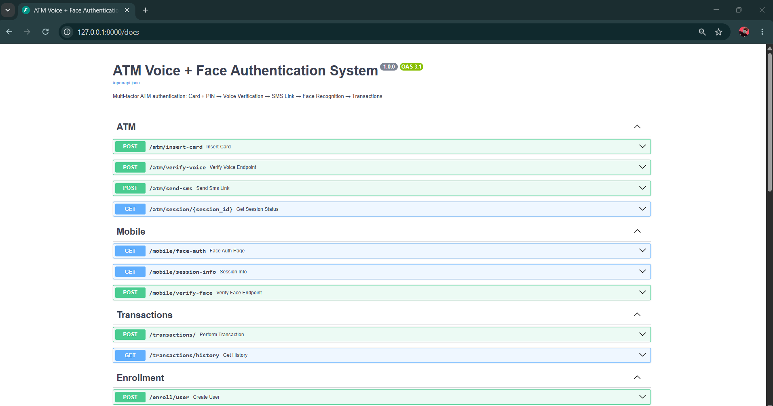
Figure 4.1: Backend Endpoints
The main backend application file sets up the FastAPI application, connects the system to the database, registers the necessary routes, and serves the frontend files. The route modules as seen in the figure 4.1 above include ATM authentication, mobile verification, enrollment, and transactions. The ATM route manages card and PIN verification, session creation, SMS link generation, QR fallback, and authentication status polling. The mobile route manages token validation and face verification. The enrollment route manages user registration and face enrollment. The transaction route controls banking operations after authentication.
The backend implementation also includes utility functions for security-related operations. These include PIN hashing, PIN verification, token generation, expiry checking, and authentication helper functions. PINs are not stored as plain text; instead, they are hashed before storage and verified securely during login attempts. This improves the security of stored credentials because the actual PIN is not directly exposed in the database.

4.3 Implementation of the ATM Interface
The ATM interface serves as the first point of interaction between the user and the system. It simulates the ATM environment where the user enters card number and PIN details. The interface sends the submitted credentials to the backend for verification. If the card or PIN is invalid, access is denied. If the verification succeeds, the system proceeds to the mobile face verification stage.
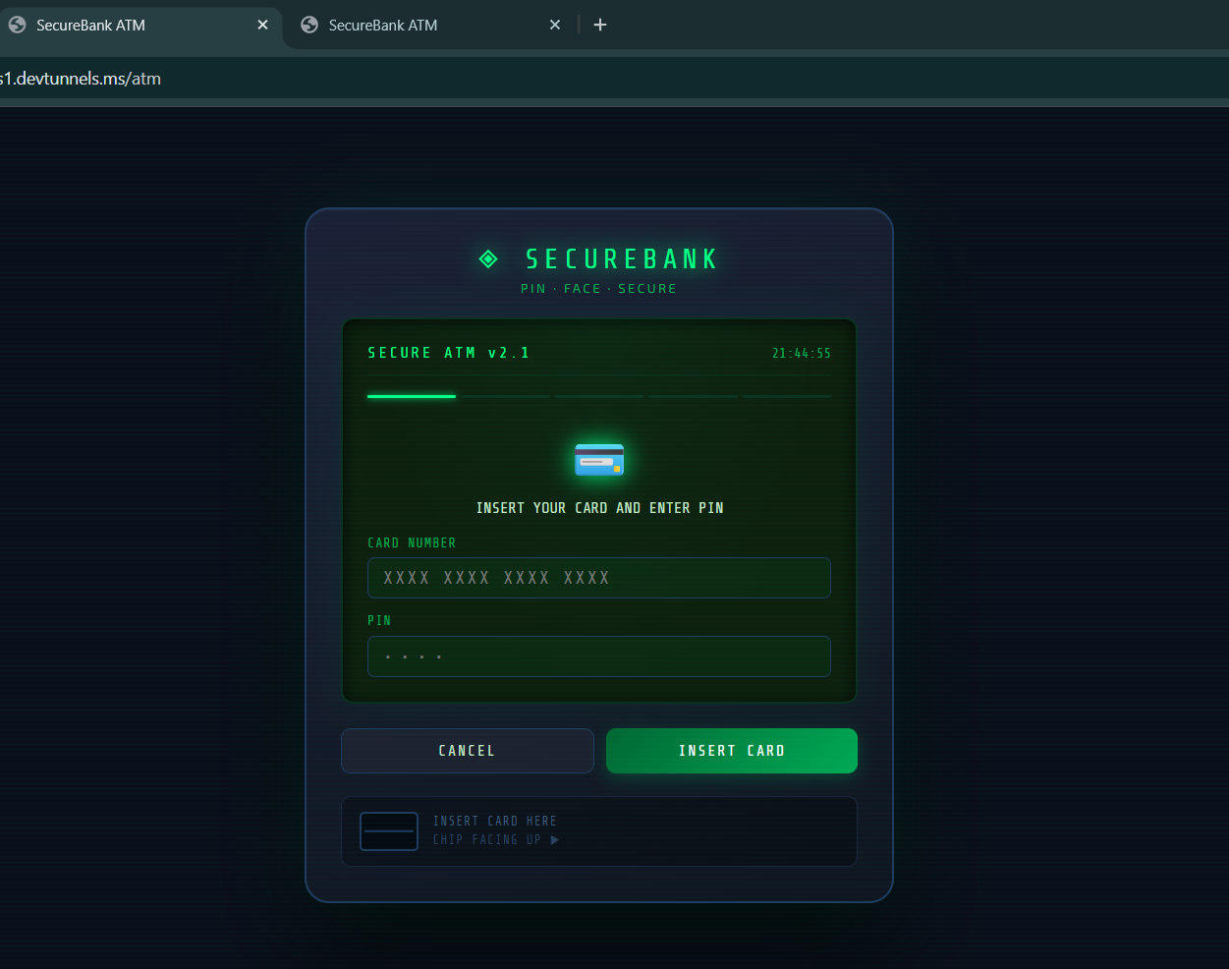
Figure 4.2: Homepage
After successful PIN verification, the ATM interface displays the next authentication instruction. The user is required to complete face verification through a mobile device. The system provides an SMS verification link and also displays a QR code fallback. The QR fallback is useful because it allows the user to open the mobile verification page even when SMS delivery is delayed or inconvenient.
The ATM interface also performs session polling. This means that the ATM page repeatedly checks the backend to know whether the mobile face verification has been completed. If the backend marks the session as authenticated, the ATM interface unlocks the transaction menu. If the token expires or verification fails, access remains denied. This design ensures that the ATM interface does not independently grant access without backend confirmation.

4.4 Implementation of the Mobile Face Verification Page
The mobile face verification page was implemented to allow the user to complete biometric verification on a mobile device. When the user opens the SMS link or scans the QR code, the mobile page loads the verification token and checks whether the session is still valid. If the token is invalid or expired, the user is not allowed to continue.
After token validation, the mobile page requests access to the phone camera. The user captures a selfie, and the captured image is submitted to the backend. The backend then compares the submitted selfie with the stored face template linked to the authenticated session. If the submitted face matches the enrolled template within the configured threshold, the session is marked as authenticated.
The use of a mobile page reduces dependence on ATM camera hardware. Instead of requiring the ATM terminal to capture the user’s face, the system uses the customer’s mobile device as the face-capture interface. This makes the prototype easier to implement and test while still demonstrating how biometric verification can be integrated into ATM authentication.

4.5 Implementation of Face Enrollment and Verification
Face enrollment is the process of registering the user’s facial template in the system. During enrollment, the system accepts face image input, extracts the face encoding, and stores the encoding in the user record. The system supports multi-angle face enrollment by allowing more than one face image to be uploaded. Valid face encodings are combined into one averaged face template for storage. This improves enrollment coverage because the stored template is not based on only one facial angle.
Face verification is performed when the user submits a selfie through the mobile verification page. The backend receives the selfie, extracts the face encoding, and compares it with the enrolled face template. The comparison uses a distance-based matching process. If the calculated distance is within the accepted threshold, the user is verified. If the distance is outside the accepted threshold, the verification fails.
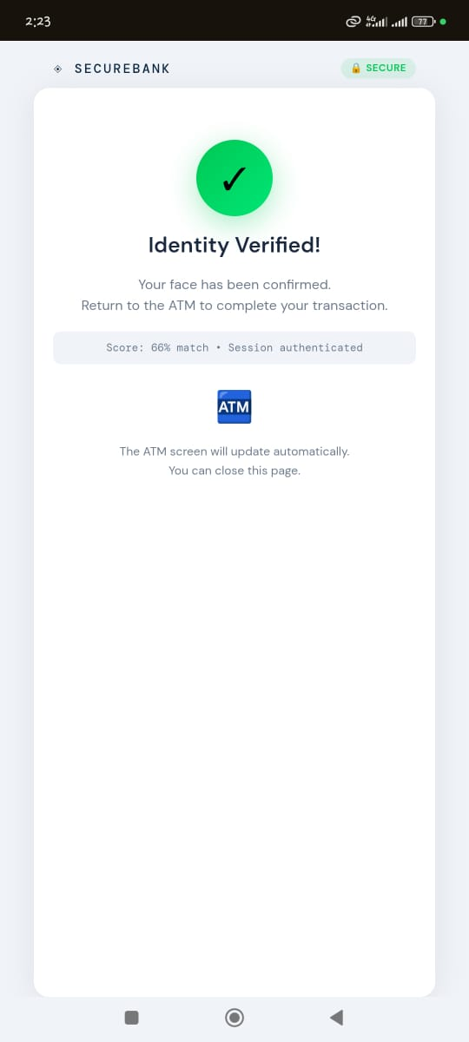

The system checks the token and session status before processing the face verification request. This prevents expired or invalid verification links from being used. It also ensures that the face verification attempt is connected to an existing authentication session. Therefore, facial verification is not performed as an isolated image comparison; it is part of a controlled authentication workflow.

4.6 Implementation of SMS and QR Verification
The SMS component was implemented to deliver the mobile face-verification link to the user’s registered phone number. After successful PIN verification, the backend generates a temporary face-verification token and creates a verification URL. The SMS service then sends the URL to the registered phone number. The SMS message allows the user to open the mobile verification page and complete the face authentication process.
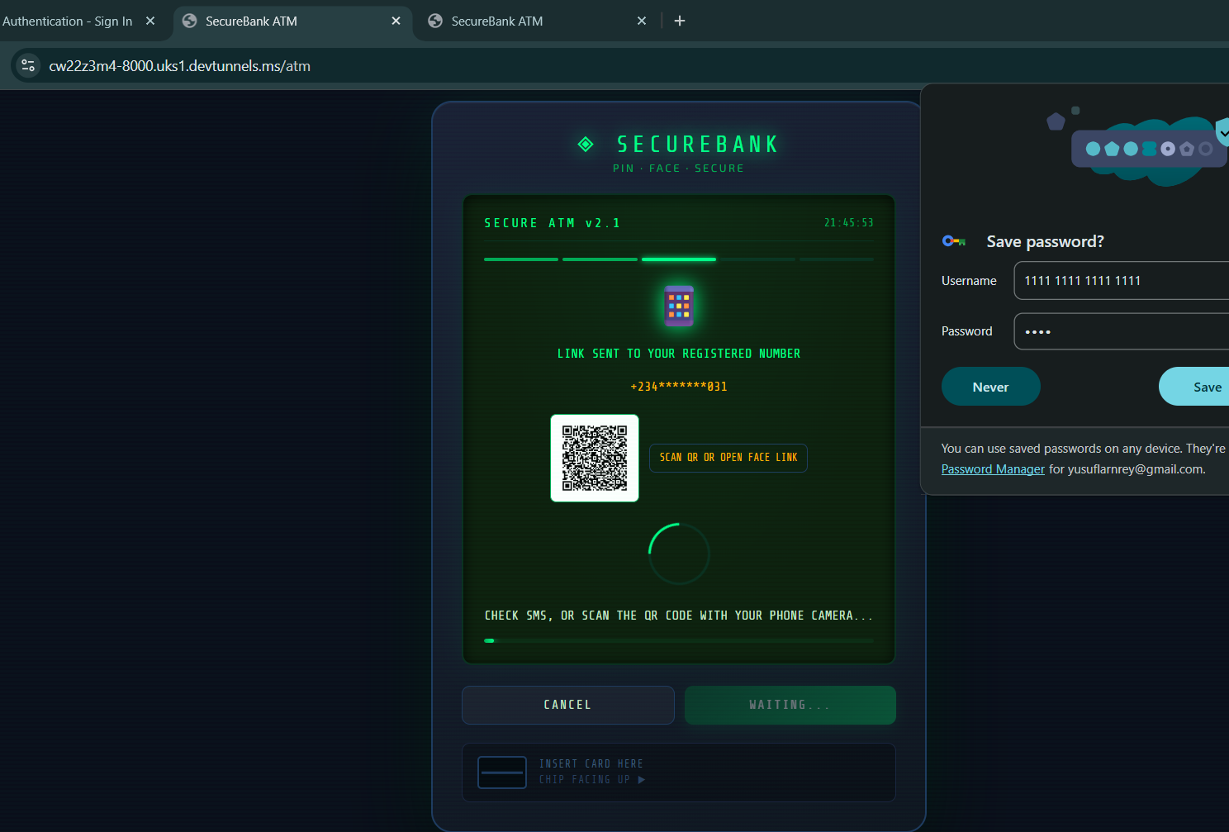
The QR fallback was implemented to provide an alternative method of accessing the mobile verification page. The ATM interface displays a QR code linked to the same verification token. The user can scan the code with a mobile device and proceed to the face verification page. This improves usability because the authentication process does not depend entirely on SMS delivery.
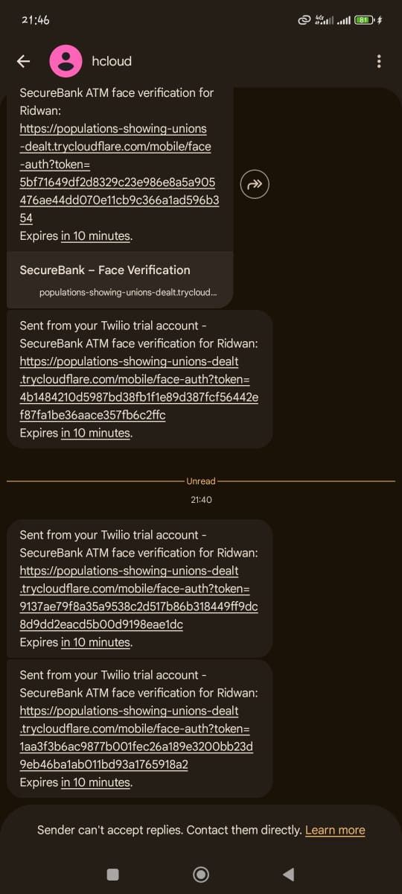
Both SMS and QR verification depend on the temporary face-verification token. The token is valid only for a limited period. If the user fails to complete verification before the token expires, the system denies access. This prevents the verification link from remaining valid indefinitely.

4.7 Implementation of Transaction Operations
The transaction module was implemented to allow authenticated users to perform basic ATM operations. These operations include balance enquiry, withdrawal, deposit, transfer, and transaction history. However, the system does not allow access to these functions until the authentication session has been marked as authenticated.
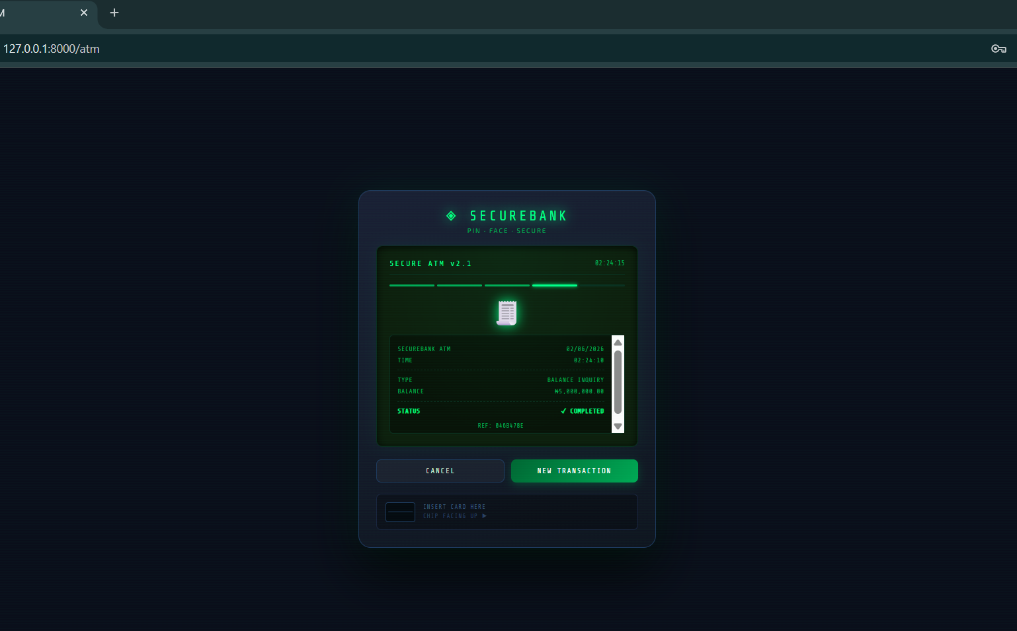
Before any transaction is processed, the backend checks whether the session exists, whether it has expired, and whether the session stage is authenticated. If these checks fail, the transaction request is rejected. This ensures that users cannot bypass the authentication workflow and proceed directly to banking operations.
The withdrawal operation checks whether the account has sufficient balance before processing the request. The system also includes a single withdrawal limit. The deposit operation updates the account balance after a valid deposit request. The transfer operation checks whether the recipient account exists and whether the sender has sufficient balance. The transaction history operation retrieves previous transaction records linked to the account. These controls ensure that transaction operations are tied to authenticated sessions and valid account records.

CHAPTER FIVE
SUMMARY, CONCLUSION, AND RECOMMENDATIONS
5.1 Summary
This study was undertaken to address the documented security limitations of traditional ATM authentication systems, which rely primarily on card and PIN verification as the principal means of granting user access. Because conventional ATM authentication systems validate credentials rather than confirm the physical identity of the person presenting those credentials, unauthorised individuals who obtain a valid card and corresponding PIN may gain fraudulent access to a bank account. This gap in identity assurance provided the central justification for the study. Therefore, the study designed and implemented a web-based multi-factor ATM authentication prototype that integrates PIN verification, SMS-based mobile handoff, and facial biometric verification as a layered access control mechanism.
The system was developed using the prototype model as the guiding software development methodology. The implementation comprised a FastAPI backend application, a PostgreSQL relational database, a browser-based ATM interface, an SMS delivery service, and a mobile face verification interface. The authentication workflow follows a staged process. The user first enters card number and PIN details through the ATM interface. After successful PIN verification, the backend creates an authentication session and generates a time-bound face-verification token. The token is delivered to the user's registered phone number through SMS, with a QR code fallback displayed on the ATM interface to improve accessibility. The user then opens the mobile verification link on a mobile device, captures a selfie through the mobile browser camera, and submits the image for facial comparison. Access to ATM transaction functions is granted only after the backend confirms that the facial verification has succeeded within the token's validity period. This sequential structure reflects the study's central argument that ATM access should be conditional on identity verification rather than credential presentation alone.
The system also supports multi-angle face enrolment. During enrolment, multiple face images may be submitted, and valid face encodings extracted from each image are averaged into a single stored template. This process improves the reliability of subsequent facial comparisons by accounting for angular variation in the enrolled reference. Transaction operations, including balance enquiry, withdrawal, deposit, transfer, and transaction history retrieval, are protected by backend session validation checks, ensuring that no banking function can be accessed without a fully authenticated session.
Testing of the system components confirmed the correct behaviour of PIN hashing and verification, token generation and expiry control, face encoding extraction and distance-based comparison, face encoding serialisation, SMS development-mode behaviour, phone number masking, and request schema validation. These results demonstrate that the core authentication logic of the prototype functions as intended and that the principal utility components of the system perform in alignment with the requirements established at the design stage.
5.2 Conclusion
The study successfully achieved its stated aim of designing and implementing a multi-modal ATM authentication prototype that enhances ATM access security through the application of layered identity verification. The implemented system moves beyond the single-stage card-and-PIN model by introducing a three-factor authentication process that incorporates a knowledge factor in the form of PIN verification, a possession and out-of-band factor through SMS and QR-assisted mobile handoff, and an inherence factor through facial biometric verification. The staged workflow ensures that access to banking functions is conditional on the successful completion of all verification stages rather than on the submission of a single credential.
The theoretical foundations reviewed in the study confirm that ATM security cannot be adequately assured through credential-based authentication alone. The Multi-Factor Authentication Framework shows that stronger authentication requires the use of either a multi-factor authenticator or a combination of separate authenticators operating across independent factor categories.
The prototype demonstrates that layered ATM authentication is achievable through software-based implementation without requiring specialised ATM hardware at the point of biometric capture. The use of a mobile browser for face capture eliminates dependence on embedded biometric sensors at ATM terminals, making the design practically extensible to existing banking infrastructure. The inclusion of both SMS delivery and QR code fallback improves usability by providing users with more than one route through which to access the face verification stage, thereby reducing the risk that a single delivery failure would prevent authentication completion.
However, the study acknowledges several important limitations that qualify the scope of its conclusions. The system is a software prototype and is not connected to real ATM hardware, core banking infrastructure, or physical card reading equipment. No formal biometric performance evaluation was conducted, and biometric performance metrics such as false acceptance rate, false rejection rate, and equal error rate were not measured. The system does not include face liveness detection, presentation attack detection, account lockout mechanisms, rate limiting, production-level encrypted biometric template storage, or real-time fraud monitoring. These limitations confirm that the prototype should be interpreted as a functional academic demonstration of multi-factor ATM authentication rather than as a production-ready banking system. Nevertheless, the prototype succeeds in establishing a working proof of concept for layered ATM authentication and contributes to the ongoing scholarly discussion on strengthening financial access control through multi-modal identity verification.
5.3 Recommendations
Based on the findings, limitations, and outcomes of the study, the following recommendations are made for future research and system development.
i. Integration of Face Liveness Detection
Future iterations of the system should incorporate liveness detection mechanisms to distinguish between a live human face and presentation attacks involving printed photographs, screen-replayed video, or mask-based spoofing. NIST (2025) identified presentation attack detection as a relevant security concern in biometric authentication contexts. The absence of liveness detection represents a known vulnerability in the current prototype, and its integration in subsequent versions would significantly improve the anti-spoofing capability of the facial verification component.
ii. Formal Biometric Performance Evaluation
Subsequent research should conduct empirical biometric evaluation using standardised datasets and established performance metrics, including false acceptance rate, false rejection rate, and equal error rate. Formal evaluation would permit the face verification threshold to be calibrated for specific operational environments and would provide evidence-based assurance of the biometric component's accuracy. Such evaluation is necessary before the system could be considered for deployment in a live banking context.
iii. Encrypted Biometric Template Storage
The security of stored face encodings should be strengthened through the application of cryptographic template protection techniques. Future implementations should explore cancelable biometrics, fuzzy commitment schemes, or secure vault approaches as mechanisms for protecting enrolled facial templates. Jain, Nandakumar, and Nagar (2008) noted that biometric template security requires attention to revocability, diversity, and resistance to attack, and these principles should guide the storage architecture of any production version of the system.

REFERENCES
Aljuaid, S. M., & Ansari, A. S. (2022). Automated Teller Machine authentication using biometric. Computer Systems Science & Engineering, 41(3). DOI: 10.32604/csse.2022.020785.
Anwar, N. M. (2025). Multiple biometric authentication for online banking system using fuzzy logic within multi-factor authentication framework.
Carrillo-Torres, D., Gómez, C., Rodríguez, G., & others. (2023). A novel multi-factor authentication algorithm based on image selection and user-established relations. Applied Sciences, 13(3), 1374.
Federal Bureau of Investigation. (n.d.). Skimming. FBI.
FSD Africa. (2017). Biometrics in digital financial services: An overview.
International Organization for Standardization. (2022). ISO/IEC 2382-37:2022: Information technology—Vocabulary—Part 37: Biometrics.
Jain, A. K., Nandakumar, K., & Nagar, A. (2008). Biometric template security. EURASIP Journal on Advances in Signal Processing, 2008, Article 579416.
Joint Task Force. (2020). Security and privacy controls for information systems and organizations (NIST Special Publication 800-53 Rev. 5). National Institute of Standards and Technology.
National Institute of Standards and Technology. (2025). Digital identity guidelines: Authentication and authenticator management (NIST Special Publication 800-63B-4).
Otta, S. P., Panda, S., & others. (2023). A systematic survey of multi-factor authentication for online banking. Future Internet, 15(4), 146.
Patil, B., Kadam, G., Dedgaonkar, I., Pansare, M., & Ghuge, C. (2025). Next generation ATM: Biometric and face authentication.
Rose, S., Borchert, O., Mitchell, S., & Connelly, S. (2020). Zero trust architecture (NIST Special Publication 800-207). National Institute of Standards and Technology.
Tran-Truong, P. T., Tandon, A., & others. (2025). A systematic review of multi-factor authentication in digital payment systems. Journal of Systems Architecture.
Widjaja, G. (2025). Implementation of biometric technology to enhance security and accessibility in digital financial services.
World Bank. (2023). Customer authentication 2.0: Approaches and innovations in fast payment systems.

